DAA Assignment-06
- Write a program to sort the array elements using Quick Sort Technique.
Ans: #include <iostream>
using namespace std;

void userDefinedSwap(int &x, int &y) {
int temp = x;
x = y;
y = temp;
}

int userDefinedPartition(int arr[], int start, int end) {
int pivot = arr[end];
int i = start - 1;

for (int j = start; j < end; j++) {
if (arr[j] <= pivot) {
i++;
userDefinedSwap(arr[i], arr[j]);
}
}
userDefinedSwap(arr[i + 1], arr[end]);
return i + 1;
}

void userDefinedQuickSort(int arr[], int start, int end) {
if (start < end) {
int partitionIndex = userDefinedPartition(arr, start, end);

userDefinedQuickSort(arr, start, partitionIndex - 1);
userDefinedQuickSort(arr, partitionIndex + 1, end);
}
}

void userDefinedDisplay(int arr[], int size) {
for (int i = 0; i < size; i++) {
cout << arr[i] << " ";
}
cout << endl;
}

int main() {
int arr[] = {25, 17, 31, 13, 2};
int n = sizeof(arr) / sizeof(arr[0]);

cout << "Original Array: ";
userDefinedDisplay(arr, n);

userDefinedQuickSort(arr, 0, n - 1);

cout << "Sorted Array: ";
userDefinedDisplay(arr, n);

return 0;
}

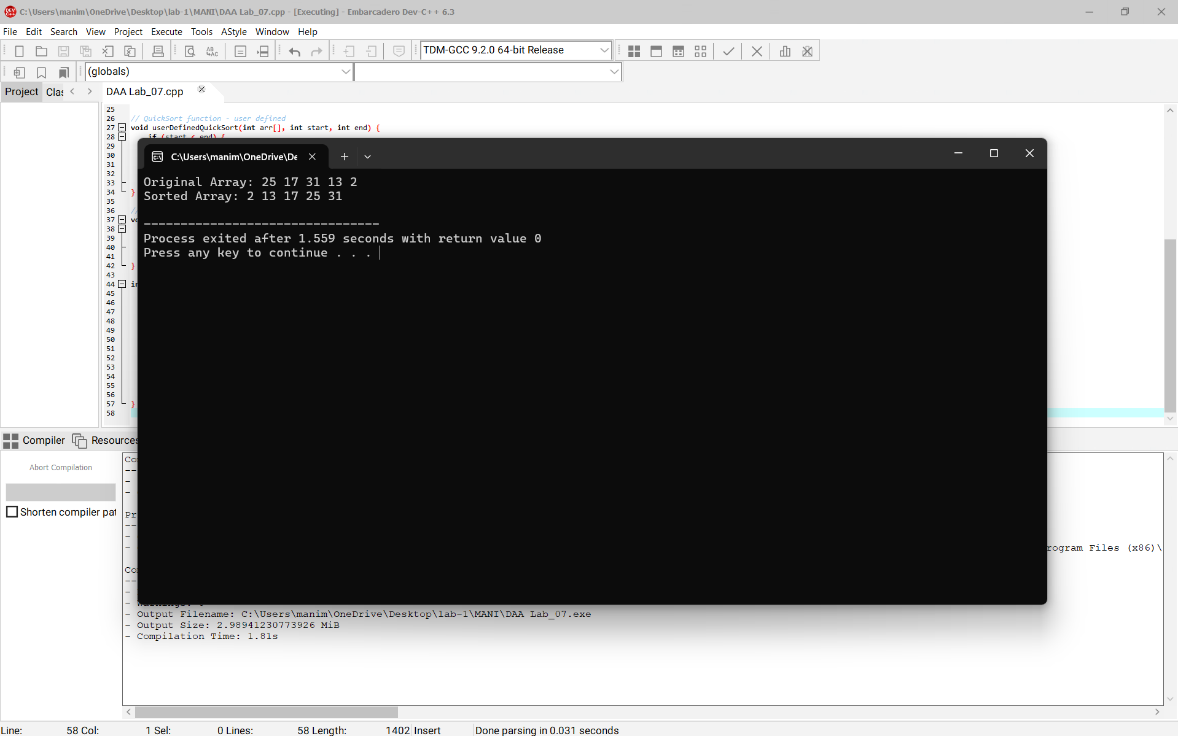
Time complexity for this code is O(n^2)
Space complexity for this code isO(n)
2. Divide and conquer: Implementation of Strassen’s algorithm for matrix multiplication.
Also analyze how this approach is advantage when compared to normal multiplication
Ans: #include <iostream>
#include <vector>
using namespace std;

typedef vector<vector<int>> Matrix;

Matrix createMatrix(int n) {
return Matrix(n, vector<int>(n, 0));
}

Matrix add(const Matrix &A, const Matrix &B) {
int n = A.size();
Matrix result = createMatrix(n);
for (int i = 0; i < n; i++)
for (int j = 0; j < n; j++)
result[i][j] = A[i][j] + B[i][j];
return result;
}

Matrix subtract(const Matrix &A, const Matrix &B) {
int n = A.size();
Matrix result = createMatrix(n);
for (int i = 0; i < n; i++)
for (int j = 0; j < n; j++)
result[i][j] = A[i][j] - B[i][j];
return result;
}

Matrix strassen(const Matrix &A, const Matrix &B) {
int n = A.size();

if (n == 1) {
Matrix result(1, vector<int>(1));
result[0][0] = A[0][0] * B[0][0];
return result;
}

int mid = n / 2;

Matrix A11(mid, vector<int>(mid));
Matrix A12(mid, vector<int>(mid));
Matrix A21(mid, vector<int>(mid));
Matrix A22(mid, vector<int>(mid));

Matrix B11(mid, vector<int>(mid));
Matrix B12(mid, vector<int>(mid));
Matrix B21(mid, vector<int>(mid));
Matrix B22(mid, vector<int>(mid));

for (int i = 0; i < mid; i++) {
for (int j = 0; j < mid; j++) {
A11[i][j] = A[i][j];
A12[i][j] = A[i][j + mid];
A21[i][j] = A[i + mid][j];
A22[i][j] = A[i + mid][j + mid];

B11[i][j] = B[i][j];
B12[i][j] = B[i][j + mid];
B21[i][j] = B[i + mid][j];
B22[i][j] = B[i + mid][j + mid];
}
}

Matrix M1 = strassen(add(A11, A22), add(B11, B22));
Matrix M2 = strassen(add(A21, A22), B11);
Matrix M3 = strassen(A11, subtract(B12, B22));
Matrix M4 = strassen(A22, subtract(B21, B11));
Matrix M5 = strassen(add(A11, A12), B22);
Matrix M6 = strassen(subtract(A21, A11), add(B11, B12));
Matrix M7 = strassen(subtract(A12, A22), add(B21, B22));

Matrix C11 = add(subtract(add(M1, M4), M5), M7);
Matrix C12 = add(M3, M5);
Matrix C21 = add(M2, M4);
Matrix C22 = add(subtract(add(M1, M3), M2), M6);

Matrix C(n, vector<int>(n));
for (int i = 0; i < mid; i++) {
for (int j = 0; j < mid; j++) {
C[i][j] = C11[i][j];
C[i][j + mid] = C12[i][j];
C[i + mid][j] = C21[i][j];
C[i + mid][j + mid] = C22[i][j];
}
}

return C;
}

void printMatrix(const Matrix &M) {
for (const auto &row : M) {
for (int val : row)
cout << val << " ";
cout << endl;
}
}

int main() {
int n;

cout << "Enter matrix size (must be power of 2): ";
cin >> n;

Matrix A(n, vector<int>(n));
Matrix B(n, vector<int>(n));

cout << "Enter elements of Matrix A:\n";
for (int i = 0; i < n; i++)
for (int j = 0; j < n; j++)
cin >> A[i][j];

cout << "Enter elements of Matrix B:\n";
for (int i = 0; i < n; i++)
for (int j = 0; j < n; j++)
cin >> B[i][j];

Matrix C = strassen(A, B);

cout << "Result of Matrix A x B using Strassen's Algorithm:\n";
printMatrix(C);

return 0;
}
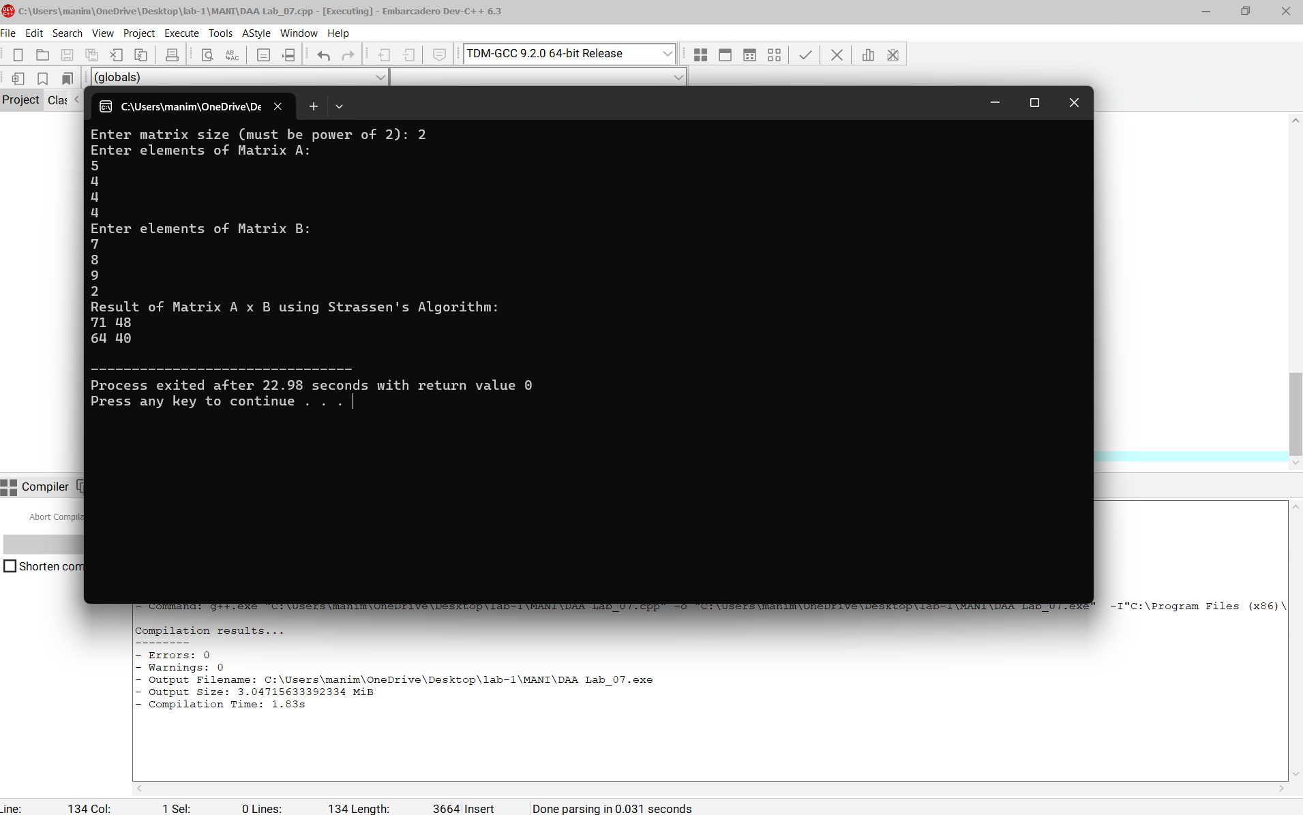
Time complexity for this code is O(n^3)
Space compleity for this code is O(n^2)

